**Nano3s Udisk Upgrade System Instructions**

This paper describes the nano3s Udisk upgrade system, first burn the image to the U disk, and then upgrade.

## 1. Burn to Udisk

This section describes how to burn an upgrade image to Udisk.

### 1.1. windows reference：

**1.1.1** Insert the Udisk into the computer, open the rufus tool, click the select button in the tool interface, and select Udisk image**.** # The nano3s/output/ directory is available after normal compilation see the Avalon_Nano3s_USB_2025012122_b377540.aup.img.gz file.

Reference:

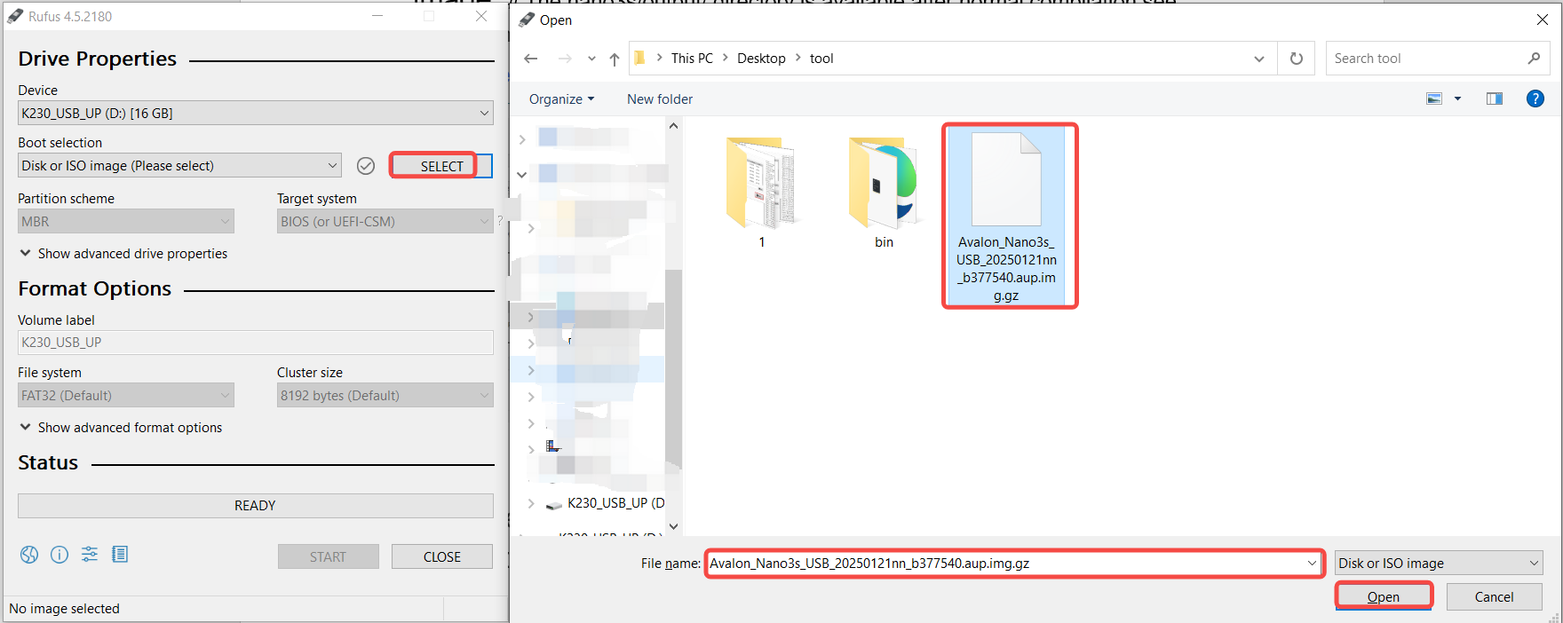

**1.1.2** Select the USB flash drive to burn, click the "Start" button to start burning, and wait for completion

There is a progress bar showing the burning process, and when the burning is finished, it will say "Ready".

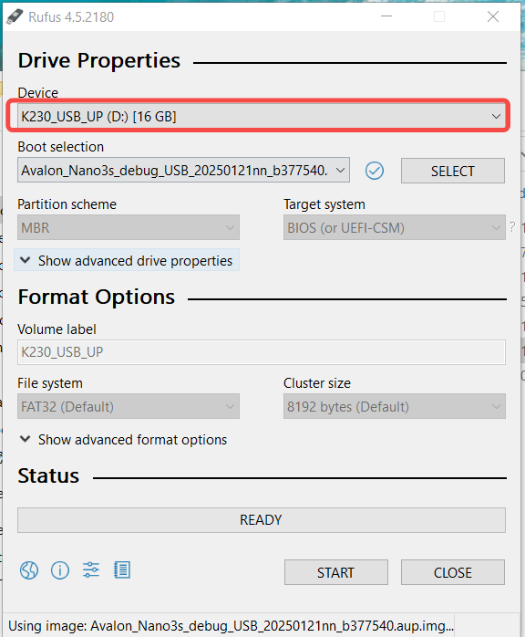

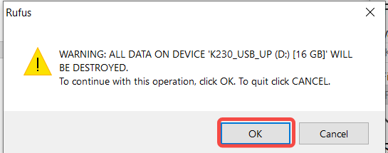

Burning medium interface:

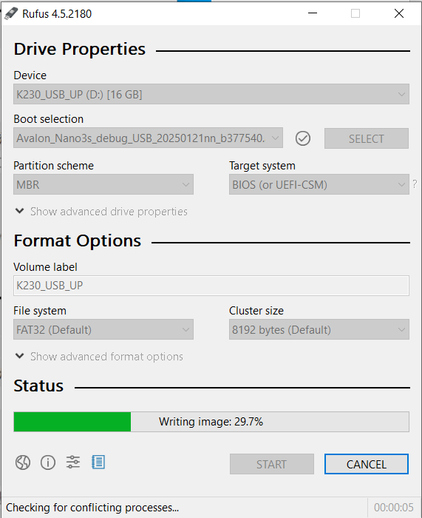

Burn completion interface:

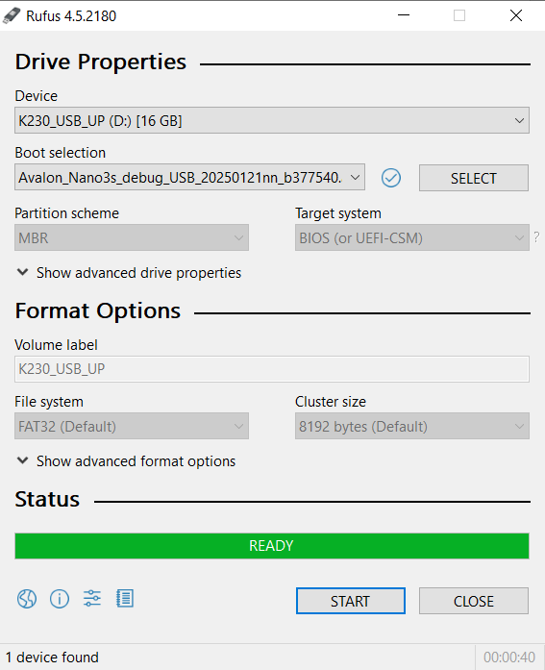

## 2. The Udisk is inserted into the nano3s for upgrading

### 2.1 Power off the nano3s, insert the USB key into the nano3s, and then power on the nano3s. Nano3s startup will detect the Udisk upgrade file, and upgrade.

After the upgrade starts, the LCD screen will display the upgrade progress. The interface is as follows:



If the upgrade is successful, the LCD screen will indicate that the upgrade is successful. The interface is as follows:

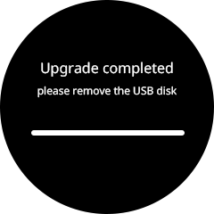

If the upgrade fails, the LCD screen will indicate that the upgrade failed, and the interface is as follows:

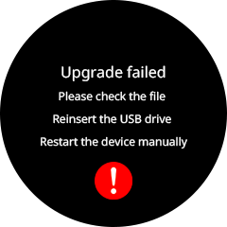

### 2.2 Please plug the Wi-Fi Receiver module and power the nano3s back on.